**Implementation Plan for Wave Stretching**

**Introduction**

Wave stretching is an extension to the strip-theory solution, for both strip-theory-only and hybrid models (the potential-flow solution is unaffected by wave stretching). Wave stretching allows for the wave kinematics and hydrodynamic loads to be computed at all nodes within the fluid domain up to the instantaneous free surface (above the still-water level (SWL) in a wave crest and below SWL in a wave trough), unlike models without wave stretching, which compute wave kinematics and loads at nodes between the seabed and SWL regardless of the instantaneous free surface. This plan includes details for adding *vertical stretching* (*WaveStMod* = 1), *extrapolated stretching* (*WaveStMod* = 2), and *Wheeler stretching* (*WaveStMod* = 3) with a load redistribution formulation designed to avoid discontinuities in the nodal loads while maintaining the instantaneous total loads.

Wave stretching applies to the velocity, flow acceleration, and dynamic pressure terms of the wave kinematics and the current velocity, which, in turn, affects the hydrodynamic added-mass, fluid-inertia, and viscous-drag terms of the distributed loads along members and the lumped loads at end joints (Note that we do not allow joints to enter or exit water during the simulation if wave-stretching is enabled). Wave stretching does not affect the exterior buoyancy, marine growth, or ballasting/flooded buoyancy terms of the loads. When wave stretching is disabled (*WaveStMod* = 0), the solution is the same as prior versions of *SeaState*/*HydroDyn*.

**Theoretical Background**

The incident wave elevation, $ζ(t;X,Y)$, fluid velocity, $v_{f}\left(t;X,Y,Z\right)$, fluid acceleration, $a_{f}\left(t;X,Y,X\right)$, and hydrodynamic pressure, $P_{dyn}\left(t;X,Y,X\right)$, are given by

|  |  |  |
| --- | --- | --- |
|  | $$ζ\left(t;X,Y\right)=ζ^{\left(1\right)}\left(t;X,Y\right)+ζ^{\left(2+\right)}\left(t;X,Y\right)+ζ^{\left(2-\right)}\left(t;X,Y\right),$$ | (1) |
|  | $$v_{f}\left(t;X,Y,Z\right)=v_{f}^{\left(1\right)}\left(t;X,Y,Z\right)+v_{f}^{\left(2+\right)}\left(t;X,Y,Z\right)+v_{f}^{\left(2-\right)}\left(t;X,Y,Z\right)+v_{current}\left(t;Z\right),$$ | (2) |
|  | $$a_{f}\left(t;X,Y,Z\right)=a_{f}^{\left(1\right)}\left(t;X,Y,Z\right)+a_{f}^{\left(2+\right)}\left(t;X,Y,Z\right)+a_{f}^{\left(2-\right)}\left(t;X,Y,Z\right),$$ | (3) |
|  | $$P_{dyn}\left(t;X,Y,Z\right)=P_{dyn}^{\left(1\right)}\left(t;X,Y,Z\right)+P_{dyn}^{\left(2+\right)}\left(t;X,Y,Z\right)+P_{dyn}^{\left(2-\right)}\left(t;X,Y,Z\right),$$ | (4) |

where (1), (2+), and (2-) indicates first-order, second-order sum frequency, and second-order difference-frequency components, respectively.

*Vertical stretching (WaveStMod = 1)*

Vertical stretching means that wave kinematics in a wave crest (above the SWL to the instantaneous free surface) are computed using values at the SWL. Wave kinematics below the SWL are not modified; however, the wave loads are only computed up to $ζ\left(t;X,Y\right)<0$ in a wave trough. The vertically stretched wave and current kinematics (indicated by ~) are as follows [1]:

|  |  |  |
| --- | --- | --- |
|  |  | (5) |
|  |  | (6) |
|  |  | (7) |

With Eq. (5)-(7), the wave kinematics and the dynamic pressure can be evaluated anywhere within $X,Y∈(-∞,+∞)$ and $Z∈[-h,+∞)$, where $h$ is the water depth. Of course, the resulting wave kinematics and pressure have no physical meaning when $Z>ζ(t;X,Y)$.

*Extrapolation Stretching (WaveStMod = 2)*

Extrapolation stretching means that wave kinematics in a wave crest (above SWL to the instantaneous free surface) are computed using values at SWL plus a linear extrapolation based on the $Z$-derivatives of the first-order wave kinematics at SWL ($Z=0$). Wave kinematics below SWL are not modified; however, the wave loads are only computed up to $ζ\left(t;X,Y\right)<0$ in a wave trough. It is noted that the $Z$-derivatives of the second-order wave kinematics is not included in the linear extrapolation, which is consistent with second order theory; effectively, the second-order terms are vertically stretched. Likewise, the slope of the current profile is not included in the linear extrapolation because such extrapolation is known to over-predict the current speed in wave crests; effectively, the current terms are also vertically stretched. The stretched wave and current kinematics, indicated by ~, are as follows:

|  |  |  |
| --- | --- | --- |
|  |  | (8) |
|  |  | (9) |
|  |  | (10) |

where

|  |  |  |
| --- | --- | --- |
|  |  | (11) |
|  |  | (12) |
|  |  | (13) |

As with vertical stretching, Eq. (8)-(10) allow the wave kinematics and dynamic pressure to be evaluated anywhere within $X,Y∈(-∞,+∞)$ and $Z∈[-h,+∞)$, but the results have no physical meaning when $Z>ζ(t;X,Y)$. In Eqs. (11)-(13), $ω_{n}$ and $k_{n}$ are the angular frequency and scalar wave number of wave component $n$, with

|  |  |  |
| --- | --- | --- |
|  | $$\frac{ω_{n}^{2}}{g}=k_{n}\tanh\left(k_{n}h\right).$$ | (14) |

The directional wave number is given by $k_{n}=\left(k_{n}\cos{β_{n}},k_{n}\sin{β_{n}}\right)$, where $β_{n}$ is the direction of wave component $n$. With $X=(X,Y)$, we have $k_{n}⋅X=k_{n}\left(\cos{β_{n}}X+\sin{β_{n}}Y\right)$. The discrete Fourier transform (DFT) amplitude of wave component $n>0$ is given by

|  |  |  |
| --- | --- | --- |
|  | $X_{n}=\frac{N^{'}}{2}A_{n}e^{iϕ_{n}}$ for $n=1,… , N^{'}/2$ | (15) |

where $A_{n}$ is the wave amplitude, $ϕ_{n}$ is the phase, and $N'$ is the total number of wave components. In OpenFAST, $N'$ is always an even number. Frequency components with $n∈\left[1,\frac{N^{'}}{2}-1\right]$ have positive frequencies, and the components with $n∈\left[-\frac{N^{'}}{2}+1,-1\right]$ have negative frequencies with DFT amplitudes given by $X_{n}=X_{-n}^{*}$. Both the DC component with $n=0$ and the Nyquist component with $n=N^{'}/2$ are always zero. Note that the expressions in the curly brackets in Eqs. (11)-(13) are the arguments for the inverse discrete Fourier transform (IDFT). Note that $X_{n}$ is not available with *WaveMod* = 6, in which case extrapolation stretching cannot be used. Vertical and Wheeler stretching are still supported with *WaveMod* = 6.

*Wheeler Stretching (WaveStMod = 3)*

Wheeler stretching is based on linearly remapping the wave kinematics and dynamic pressure previously defined between the seabed and the SWL, $Z∈[-h,0]$, to $Z∈[-h,ζ(t;x,y)]$. In other words, the wave-field variables at a point $(X,Y,Z)$ is now given by that at $\left(X,Y,Z^{'}\right)$ in the original unstretched wave field, where $Z'$ is given by

|  |  |  |
| --- | --- | --- |
|  | $$Z^{'}=h\frac{h+Z}{h+ζ\left(t;X,Y\right)}-h.$$ | (16) |

With $Z∈[-h,ζ(t;X,Y)]$, we have $Z^{'}∈[-h,0]$.

**Input File Changes**

*WaveStMod* = 0 (no wave stretching) is kept as an option and *WaveStMod* = 1, 2, and 3 will be enabled. *WaveStMod* = 1 is for vertical stretching; *WaveStMod* = 2 is for extrapolation stretching; and *WaveSTMod* = 3 is for Wheeler stretching. *WaveStMod* is unused when *WaveMod* = 0 or for potential-flow-only solutions (*NMembers* = 0). When *WaveMod* = 6, extrapolation stretching with *WaveStMod* = 2 is not supported.

**Distributed Loads**

*Fluid Inertia, Added Mass, Viscous Drag*

The range of $Z$-position over which the distributed fluid inertia, added mass, and viscous drag is evaluated depends on the *WaveStMod*. This information is summarized in Table 1. Except for viscous drag, all other load components will only be evaluated when *PropPot* = False. Also, *WaveStMod* is only relevant when *WaveMod* ≠ 0 (no wave) or 6 (user defined wave kinematics).

**Table 1**. Range of $z$-position over which the distributed fluid inertia, added mass, and viscous drag are evaluated.

|  |  |  |  |  |
| --- | --- | --- | --- | --- |
| **Dist. Load** | **Symbol** | **PropPot** | $z$**-Range** | |
| *WaveStMod* = 0 or *WaveMod* = 0 | *WaveStMod* > 0 and  *WaveMod* ≠ 0 |
| Fluid Inertia | $$F_{I}$$ | False | [–WtrDpth,MSL2SWL] | [–WtrDpth,MSL2SWL+ $ζ(t;X,Y)$] |
| Added Mass | $$F_{AM_M}$$ | False | [–WtrDpth,MSL2SWL] | [–WtrDpth,MSL2SWL+ $ζ(t;X,Y)$] |
| Viscous Drag | $$F_{D}$$ | True/False | [–WtrDpth,MSL2SWL] | [–WtrDpth,MSL2SWL+ $ζ(t;X,Y)$] |

*Exterior Buoyancy, Ballasting/Flooded Buoyancy, Ballasting/Flooded Mass Inertia, Marine-Growth Weight, Marine-Growth Mass Inertia*

These contributions to the distributed loads are not affected by wave stretching.

**Lumped Loads**

With wave stretching, the lumped loads will be evaluated based on the stretched wave field as well. However, we do not allow end joints initially above the waterline to become submerged or for submerged joints to move out of the water during the simulation. In other words, end joints cannot cross the instantaneous free surface $ζ(t;x,y)$. Physically, end joints moving in and out of water constitutes a water entry/exit problem, which cannot be accurately modeled with the current OpenFAST formulation.

**Implementation Details**

The implementation of wave stretching is greatly facilitated by the new SeaState module, which allows the wave-field variables—fluid velocity, acceleration, dynamic pressure, and free surface elevation—to be evaluated anywhere in the fluid domain by interpolating in time and space on precomputed 3D or 4D grids (time + space).

Note that in the current implementation of wave stretching, *SeaState* is expected to provide the capability to interpolate wave-related variables on the unstretched wave field defined between the seabed and the SWL. The wave stretching is performed on an as-needed bases for each surface-piercing member during load calculations in *HydroDyn*. *SeaState* is not expected to perform any wave stretching apart from generating the outputs of wave kinematics at points requested by the user. For extrapolation stretching only however, SeaState needs to generate additional 3D grids (time and *X $,Y$*-positions on the SWL) of the $Z$-derivatives of the first-order fluid velocity, acceleration, and dynamic pressure, $∂v_{f}^{\left(1\right)}/∂Z{\left.​\right|}_{Z=0}$, $∂a_{f}^{\left(1\right)}/∂Z{\left.​\right|}_{Z=0}$, and $∂P_{dyn}^{\left(1\right)}/∂Z{\left.​\right|}_{Z=0}$, and pass them to *HydroDyn*. The preparation of and interpolation on these 3D grids can be done in the same fashion as with the wave elevation already implemented in *SeaState* and *HydroDyn*.

Furthermore, with the new *SeaState* module, the implementation of Wheeler stretching becomes trivial. We simply need to evaluate $Z'$ for each node and compute the wave-related variables using interpolation on the original unstretched wave field at $(X,Y,Z')$.

*Member Node Position*

With the new *SeaState* and *HydroDyn* implementation, the wave kinematics can now be evaluated at the instantaneous $X,Y$-positions of each member node if *WaveDisp* = 1 in the *HydroDyn* input file to obtain more accurate wave phasing when the excursion of the structure in the horizontal plane is large. With *WaveStMod* = 0, the initial $Z$-coordinate of each node is used to evaluate the relevant wave-field variables, essentially neglecting the vertical motion. With *WaveStMod* > 0 however, the instantaneous $Z$ positions of the nodes will be used. When *WaveDisp* = 0, the initial position of the nodes in all three directions is used regardless of *WaveStMod*.

*Modifications to the Distributed Hydrodynamic Loads to Avoid Discontinuity*

With wave stretching, the nodes of a member can enter and exit water. The hydrodynamic loads on nodes out of water are zeroed, leading to discontinuity in the load time series. To ensure the load variation on each node remains continuous and smooth in time, the distributed hydrodynamic loads on the first and second nodes at or below the instantaneous free-surface elevation given by $ζ(t;X,Y)$ need to be modified. Let node $i$ and $i-1$ be the first two nodes at or just below the free surface with node $i-1$ below node $i$ (this is a safe assumption because we do not allow nearly horizontal surface-piercing members). The element $i$ between node $i$ and $i+1$ is partially wetted. The distributed forces $F_{i}$ and $F_{i-1}$ at the two nodes are modified to

|  |  |  |
| --- | --- | --- |
|  | $${\tilde{F}}_{i}=F_{i}+ΔF_{1}\left(α,F_{0}=F_{i},F_{s}\right),$$ | (17) |
|  | $${\tilde{F}}_{i-1}=F_{i-1}+ΔF_{2}\left(α,F_{0}=F_{i}\right),$$ | (18) |

where $ΔF_{1}$ and $ΔF_{2}$ are the force modifications to the first and second nodes at or below the free surface, respectively. The force modifications depend on $α∈[0,1)$, the fraction of element $i$ that is wetted, the unmodified distributed force at the first node at or below the free surface, $F_{0}$, and the unmodified distributed force at the intersection between the free surface and element $i$, $F_{s}$, evaluated at $(t;X_{s},Y_{s},Z_{s})$. A polynomial function $f(α)$ is developed:

|  |  |  |
| --- | --- | --- |
|  | $$f\left(α\right)=2α^{3}-3.5α^{2}+α+0.5,$$ | (19) |

which is used to evaluate $ΔF_{1}$ and $ΔF_{2}$:

|  |  |  |
| --- | --- | --- |
|  | $$ΔF_{1}\left(α,F_{0},F_{s}\right)=\left(\frac{α-1}{2}-f\left(α\right)\right)F_{0}+\frac{α}{2}F_{s},$$ | (20) |
|  | $$ΔF_{2}\left(α,F_{0},F_{s}\right)=f\left(α\right)F_{0}.$$ | (21) |

Finally, because we have slightly modified the distribution of the hydrodynamic loads near the free surface, the total moment on the member is slightly altered. To correct the total moment, smooth distributed moment corrections (moment per unit length), $ΔM_{1}(α,F_{s})$ and $ΔM_{2}(α,F_{0})$, should be added to the first and second nodes at or below the free surface, respectively:

|  |  |  |
| --- | --- | --- |
|  | $$ΔM_{1}\left(α,F_{s}\right)=\frac{α^{2}⋅δl}{2}k×F_{s},$$ | (22) |
|  | $$ΔM_{2}\left(α,F_{0}\right)=f\left(α\right)⋅δl⋅k×F_{0},$$ | (23) |

where $k$ is the unit vector along the axis of the element. The derivation of the load-redistribution formulation is included in the Appendix along with example results.

*Identifying the Intersection Between the Instantaneous Free Surface and the Element*

To implement the load smoothing/redistribution, we need to compute the intersection of the instantaneous free surface and the axis of each surface piercing member at $(X_{s},Y_{s},Z_{s})$ at each time step. It is therefore necessary to do so efficiently with reasonable accuracy. We assume the elements of each member is fine enough so that the free surface can, at a maximum, cross each element once at a given time step. It is then straight forward to identify the element of each surface-piercing member that intersects the free surface. More specifically, if $Z_{i}(t)≤ζ\left(t;X_{i},Y_{i}\right)$ and $Z_{i+1}(t)>ζ(t;X_{i+1},Y_{i+1})$, the element $i$ between node $i$ and node $i+1$ is partially wetted, and its axis intersects with the free surface. The position of the intersection can be concisely represented by the submergence ratio $α∈\left[0,1\right)$. The linear distance between the intersection and node $i$ is given by $α⋅δl$, where $δl$ is the length of the element along its axis. To avoid an iterative solution, we can assume the free-surface elevation varies linearly between $(X_{i},Y_{i})$ and $(X_{i+1},Y_{i+1})$, and the submergence ratio $α$ can be computed as

|  |  |  |
| --- | --- | --- |
|  | $$α=\frac{ζ\left(t;X_{i},Y_{i}\right)-Z_{i}(t)}{\left(ζ\left(t;X_{i},Y_{i}\right)-Z_{i}\left(t\right)\right)-\left(ζ\left(t;X_{i+1},Y_{i+1}\right)-Z_{i+1}\left(t\right)\right)} ,$$ | (24) |

and the coordinates of the intersection follow:

|  |  |  |
| --- | --- | --- |
|  | $$\left[\begin{matrix}X_{s} \\ Y_{s} \\ Z_{s}\end{matrix}\right]=α\left[\begin{matrix}X_{i+1}-X_{i} \\ Y_{i+1}-Y_{i} \\ Z_{i+1}-Z_{i}\end{matrix}\right]+\left[\begin{matrix}X_{i} \\ Y_{i} \\ Z_{i}\end{matrix}\right].$$ | (25) |

This approach should be very accurate when the wave curvature is small, when the inclination of the member from vertical is small, and/or when $δl$ is small.

*Lumped Nodal Distributed Loads and Other Restrictions*

The lumped nodal forces and moments can be computed as is done in the current *HydroDyn* implementation simply as $δl⋅{\tilde{F}}_{i}$ and $δl⋅{ΔM}_{i}$, respectively, for the first two nodes at or below the instantaneous free surface or as $δl⋅F_{i}$ for other submerged nodes (no additional moment). The first (deepest) node of the member is an exception; the lumped nodal force should be to be consistent with the trapezoidal rule. The modification to the distributed hydrodynamic loads due to wave stretching is only relevant to surface piercing members. As with the exact buoyancy load calculation, nearly horizontal surface-piercing members should not be allowed, and the topmost element of the member should not become fully submerged during the simulation. Furthermore, we need the two lowest elements of the member to always remain fully submerged for the above load modification to remain valid. This requirement is only marginally more restrictive than that for the buoyancy force, which requires at least one element to be always fully submerged.

**Appendix: Modifications to the Distributed Hydrodynamic Loads to Avoid Discontinuity**

**Overview**

With wave stretching, the nodes of a member can enter and exit water, leading to discontinuity in the distributed hydrodynamic loads. To ensure the load variation on each node remains continuous and smooth in time, the distributed hydrodynamic loads on the first and second nodes at or below the instantaneous free-surface elevation given by $ζ(t;X,Y)$ need to be modified. The modification is inspired by the evaluation of the exact buoyancy loads but redeveloped for the distributed hydrodynamic loads.

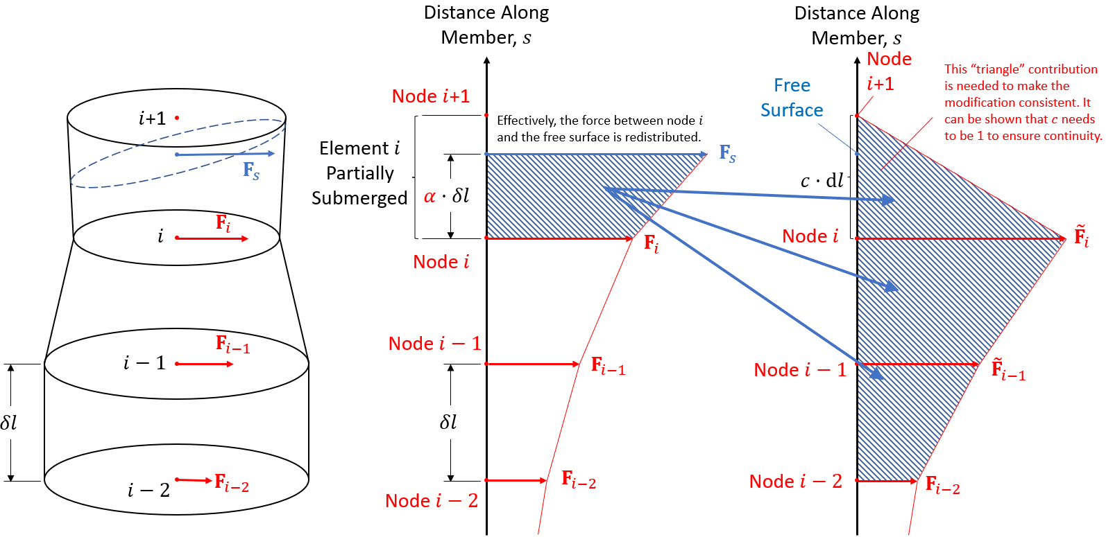

|  |  |  |
| --- | --- | --- |
| **(a)** | **(b)** | **(c)** |

**Figure 1**. Modification to the distributed hydrodynamic loads near the waterline for continuity and smoothness. **(a)** Elements of a surface-piercing member near the instantaneous free surface. The waterline is given by the dashed circle. **(b)** Exact distributed loads with wave stretching. **(c)** Modified distributed loads that ensure continuity and smoothness as the free surface moves past nodes. $F_{i}$ and $F_{s}$ represent the vector distributed hydrodynamic loads at nodal $i$ and at the instantaneous free surface.

**Modification to the Distributed Forces**

To ensure the distributed forces (force per unit length along the member) at each node change continuously and smoothly with time, even as the node enters and exits water (at which point the load is zeroed), the distributed forces on the first two nodes at or just below the instantaneous free surface are modified. Consider the scenario shown in Figure 1. Nodes $i$ and $i-1$ are the two nodes just below the free surface. The distributed forces $F_{i}$ and $F_{i-1}$ are modified to

|  |  |  |
| --- | --- | --- |
|  | $${\tilde{F}}_{i}=F_{i}+ΔF_{1}$$ | (26) |
|  | $${\tilde{F}}_{i-1}=F_{i-1}+ΔF_{2},$$ | (27) |

where $ΔF_{1}$ and $ΔF_{2}$ are the force modifications to the first and second nodes below the free surface, respectively. The element $i$ between node $i$ and node $i+1$ is partially wetted with the free surface a distance of $α⋅δl$ from node $i$ along the axis of the member, where $δl$ is the uniform length of each element of the member. We let $α∈[0,1$). In other words, we consider element $i$ to be partially submerged even if node $i$ is exactly on the free surface.

Because the incident-wave velocity and acceleration fields are smooth in time and space, the time evolution of the flow velocity and acceleration will not result in any discontinuity in the distributed hydrodynamic loads. The discontinuity is purely created by zeroing the distributed loads at nodes above the free surface, which evolves with time; therefore, in the ensuing development, we assume the flow field (velocity and acceleration) is frozen in time and defined everywhere including above the still water level and even above the instantaneous free surface based on the chosen wave-stretching method. Only the free-surface elevation and, by extension, $α$ is changing. With this assumption, a constant and smooth distributed hydrodynamic force $F$ can be evaluated at any point along the member; however, it will be zeroed above the instantaneous free surface. We also assume the member is fixed. Essentially, the requirement that the distributed force (with zeroing above the free surface) remains smooth in time can now be replaced by the requirement that it remains smooth with free-surface elevation even as the free-surface crosses nodes.

The functions $ΔF_{1}$ and $ΔF_{2}$ need to be designed to ensure smooth changes in the distributed forces at the nodes while also maintaining the total force on the member. The total force from node $i-2$ up to the free surface can be integrated along the member using the trapezoidal rule with both the original force distribution and the modified one. By equating the two, we have

|  |  |
| --- | --- |
| $$\frac{δl}{2}\left(F_{i-2}+F_{i-1}\right)+\frac{δl}{2}\left(F_{i-1}+F_{i}\right)+α\frac{δl}{2}\left(F_{i}+F_{s}\right)=\frac{δl}{2}\left(F_{i-2}+{\tilde{F}}_{i-1}\right)+\frac{δl}{2}\left({\tilde{F}}_{i-1}+{\tilde{F}}_{i}\right)+c\frac{δl}{2}{\tilde{F}}_{i},$$ | (28) |

where $c$ is an unknown constant to be determined. Because we only modify the forces on the first two nodes below the free surface, $F_{i-2}$ is not modified. After some manipulation, the equation can be simplified to

|  |  |  |
| --- | --- | --- |
|  | $$\left(1+c\right)ΔF_{1}+2ΔF_{2}=\left(α-c\right)F_{i}+αF_{s}.$$ | (29) |

The right-hand side of Eq. (29) only involves $α$, $F_{i}$, and $F_{s}$ ( $F_{i-2}$ and $F_{i-1}$ cancelled out). We therefore assume the force corrections, $ΔF_{1}$ and $ΔF_{2}$, are functions of $α$, $F_{0}$, and $F_{s}$ only, where $F_{0}$ and $F_{s}$ are the distributed hydrodynamic forces evaluated at the first node below the free surface and on the instantaneous free surface, respectively. For the configuration shown in Figure 1, we have $F_{0}=F_{i}$.

To ensure the modified forces remain continuous as the free surface moves across nodes, we need to satisfy the following three constraints:

***Constraint 1:***

Because the load on any node above the free surface will be zeroed, we need ${\tilde{F}}_{i}=0$  when $α=0$ (node $i$ is exactly on the free surface), so that ${\tilde{F}}_{i}$ remains continuous when the free surface drops below node $i$ (at which point the distributed force at node $i$ is zeroed), which leads to

|  |  |  |
| --- | --- | --- |
|  | $$ΔF_{1}\left(α=0,F_{0}=F_{i},F_{s}\right)=-F_{i} ⇒ ΔF_{1}\left(α=0,F_{0},F_{s}\right)=-F_{0}.$$ | (30) |

With this constraint, Eq. (29) leads to the following constraint on $ΔF_{2}$ when $α=0$:

|  |  |  |
| --- | --- | --- |
|  | $$ΔF_{2}\left(α=0,F_{0}=F_{i},F_{s}\right)=\frac{1}{2}F_{i} ⇒ ΔF_{2}\left(α=0,F_{0},F_{s}\right)=\frac{1}{2}F_{0}.$$ | (31) |

***Constraint 2:***

Because we do not modify the third node below the free surface, we need ${\tilde{F}}_{i-1}→F_{i-1}$  as $α→1$ (the free surface approaches node $i+1$ and node $i-1$ is on the cusp of becoming the third node below the free surface) to ensure a smooth transition as the free surface rise above node $i+1$, at which point the load at node $i-1$ will no longer be modified. Therefore,

|  |  |  |
| --- | --- | --- |
|  | $$ΔF_{2}\left(α→1,F_{0}=F_{i},F_{s}\right)→0 ⇒ ΔF_{2}\left(α→1,F_{0},F_{s}\right)→0.$$ | (32) |

With this constraint, Eq. (29) leads to the following constraint on $ΔF_{1}$ as $α→1$.

|  |  |  |
| --- | --- | --- |
|  | $$ΔF_{1}\left(α→1,F_{0}=F_{i},F_{s}\right)→\frac{\left(1-c\right)F_{i}+F_{S}}{1+c} ⇒ ΔF_{1}\left(α→1,F_{0},F_{s}\right)→\frac{\left(1-c\right)F_{0}+F_{S}}{1+c}.$$ | (33) |

***Constraint 3:***

When the free surface rise above node $i+1$, node $i$ changes from the 1st node below the free surface to the second; therefore, the modification to $F_{i}$ switches from $ΔF_{1}$ to $ΔF_{2}$, which results in a third constraint needed to ensure ${\tilde{F}}_{i}$ remains continuous when this happens.

When the free surface is just below node $i+1$ ($α→1$, $F_{0}=F_{i}$, and $F_{s}→F_{i+1}$), node $i$ is the first node below the free surface, and we have

|  |  |  |
| --- | --- | --- |
|  | $${\tilde{F}}_{i}=F_{i}+ΔF_{1}\left(α→1,F_{0}=F_{i},F_{s}→F_{i+1}\right).$$ | (34) |

When the free surface is right on node $i+1$, node $i$ becomes the second node below the free surface (node $i+1$ is now the first). In this case, we have $α=0$, $F_{0}=F_{s}=F_{i+1}$, and

|  |  |  |
| --- | --- | --- |
|  | $${\tilde{F}}_{i}=F_{i}+ΔF_{2}\left(α=0,F_{0}=F_{i+1},F_{s}=F_{i+1}\right).$$ | (35) |

For ${\tilde{F}}_{i}$  to be continuous as the free surface crosses node $i+1$, we need

|  |  |  |
| --- | --- | --- |
|  | $$ΔF_{1}\left(1,F_{i},F_{i+1}\right)=ΔF_{2}\left(0,F_{i+1},F_{i+1}\right).$$ | (36) |

Using Eq. (31) and Eq. (33) derived from the first two constraints, we have

|  |  |  |
| --- | --- | --- |
|  | $$\frac{\left(1-c\right)F_{i}+F_{i+1}}{1+c}=\frac{1}{2}F_{i+1}.$$ | (37) |

To unconditionally satisfy the above equation, we can simply choose $c=1$. This is equivalent to assuming the sectional load decays linearly to zero from the node on or just below the free surface to the node just above. Interestingly, this is consistent with the trapezoidal integration of the sectional hydrodynamic forces.

With $c=1$, we now have the following simplified constraints on the functions $ΔF_{1}$ and $ΔF_{2}$:

When $α=0$,

|  |  |  |
| --- | --- | --- |
|  | $$ΔF_{1}\left(α=0,F_{0},F_{s}\right)=-F_{0},$$ | (38) |
|  | $$ΔF_{2}\left(α=0,F_{0},F_{s}\right)=\frac{1}{2}F_{0}.$$ | (39) |

As $α→1$,

|  |  |  |
| --- | --- | --- |
|  | $$ΔF_{1}\left(α→1,F_{0},F_{s}\right)→\frac{1}{2}F_{s},$$ | (40) |
|  | $$ΔF_{2}\left(α→1,F_{0},F_{s}\right)→0.$$ | (41) |

Note that the constraints for $ΔF_{2}$ do not involve $F_{s}$. We can therefore drop the dependence on $F_{s}$ for $ΔF_{2}$. For a smooth variation of the hydrodynamic forces with $α$, we can let

|  |  |  |
| --- | --- | --- |
|  | $$ΔF_{2}\left(α,F_{0}\right)=f\left(α\right)F_{0},$$ | (42) |

with $f(α)$ being a 3rd degree polynomial function of $α$. The constraint on $ΔF_{2}$ now translates to

|  |  |  |
| --- | --- | --- |
|  | $$f\left(0\right)=\frac{1}{2},$$ | (43) |
|  | $$f\left(1\right)=0.$$ | (44) |

Invoking Eq. (29) one more time, we obtain

|  |  |  |
| --- | --- | --- |
|  | $$ΔF_{1}\left(α,F_{0},F_{s}\right)=\left(\frac{α-1}{2}-f\left(α\right)\right)F_{0}+\frac{α}{2}F_{s},$$ | (45) |

which automatically satisfies the two constraints for $ΔF_{1}$ above by construct as long as the two constraints for $f(α)$, Eq. (43) and Eq. (44), are satisfied. Final, to uniquely determine $f\left(α\right)=aα^{3}+bα^{2}+cα+d$, we enforce two additional conditions on the derivative of $ΔF_{1}$ and $ΔF_{2}$ with respect to $α$, so that ${\tilde{F}}_{i}$  approaches zero smoothly when $α=0$ and ${\tilde{F}}_{i-1}$ approaches $F_{i-1}$ smoothly as $α→1$. Note that with the assumption of a frozen velocity and acceleration field and a fixed structural member, the distributed force on any node is a constant. Therefore, the derivative of the modified forces on the first and second nodes below the free surface with respect to $α$ are equal to the derivatives of $ΔF_{1}$ and $ΔF_{2}$, respectively:

|  |  |  |
| --- | --- | --- |
|  | $$\frac{∂ΔF_{1}}{∂α}=\left(\frac{1}{2}-f^{'}\left(α\right)\right)F_{0}+\frac{1}{2}F_{S}+\frac{α}{2}\frac{dF_{s}}{dα},$$ | (46) |
|  | $$\frac{∂ΔF_{2}}{∂α}=f^{'}\left(α\right)F_{0}.$$ | (47) |

Note that $F_{0}$, the distributed force on the first node below the free surface, is independent of $α$, whereas $F_{s}$, the distributed force at the free surface, changes with $α$ because the point on the partially submerged element where $F_{s}(={\left.F\right|}_{η})$ is evaluated depends on the free-surface elevation $η$; therefore,

|  |  |  |
| --- | --- | --- |
|  |  | (48) |

where $s$ is the distance along the member which increases from node $i$ to node $i+1$. With Eq. (46) and Eq. (47), the two additional constraints become:

|  |  |  |
| --- | --- | --- |
|  |  | (49) |
|  |  | (50) |

With the two additional conditions, $f\left(α\right)$ is now uniquely determined as

|  |  |  |
| --- | --- | --- |
|  | $$f\left(α\right)=2α^{3}-3.5α^{2}+α+0.5.$$ | (51) |

The final force corrections are

|  |  |  |
| --- | --- | --- |
|  | $$ΔF_{1}\left(α,F_{0},F_{s}\right)=\left(-2α^{3}+3.5α^{2}-\frac{α}{2}-1\right)F_{0}+\frac{α}{2}F_{s},$$ | (52) |
|  | $$ΔF_{2}\left(α,F_{0}\right)=\left(2α^{3}-3.5α^{2}+α+0.5\right)F_{0}.$$ | (53) |

Finally, we can show that not only ${\tilde{F}}_{i}$  is continuous as the free surface rise above node $i+1$ (see ***Constraint 3*** above), the derivative of ${\tilde{F}}_{i}$  with respect to $α$ is also continuous when the modification to $F_{i}$ switches from $ΔF_{1}$ to $ΔF_{2}$, assuming the discretization of the element is fine enough. When the free surface is approaching node $i+1$ from below, we have $α→1$, $F_{0}=F_{i}$, $F_{s}→F_{i+1}$, and

|  |  |  |
| --- | --- | --- |
|  |  | (54) |

The second equality is based on the relation

|  |  |  |
| --- | --- | --- |
|  |  | (55) |

On the other hand, when the free surface is on node $i+1$, we have $α=0$, $F_{0}=F_{i+1}$, and

|  |  |  |
| --- | --- | --- |
|  |  | (56) |

Eq. (54) and Eq. (56) show that the derivative of the force modification is matched when switching from $ΔF_{1}$ to $ΔF_{2}$. Therefore, in conjunction with Eq. (49) and (50), the modified distributed forces are demonstrated to be $C^{1}$ continuous as the free surface moves past nodes. The force modifications defined in Eq. (52) and Eq. (53) satisfy all relevant requirements.

To illustrate the behavior of the load modification/redistribution technique developed, we can assume $F_{0}≈F_{S}$, a reasonable assumption for small $δl$ and/or long waves. This simplification allows us to plot $ΔF_{1}/F_{0}$ and $ΔF_{2}/F_{0}$ as functions of just $α$ using Eq. (52) and Eq. (53), as done in Figure 2. Figure 2 shows that $ΔF_{1}/F_{0}$ is initially at $-1$ when $α=0$ to drive the modified distributed load at the first node $i$ below the free surface to zero. The slope of $ΔF_{1}/F_{0}$ is also zero at this point. As the free-surface rises ( $α$ increases), $ΔF_{1}/F_{0}$ increases and switches sign when $α≈0.7$ (the element $i$ above node $i$ is approximately 70% submerged). For $α>0.7$, the load redistribution starts to increase the load at node $i$ instead of decreasing it. In contrast, $ΔF_{2}/F_{0}$ is always positive, meaning the load redistribution will always increase the loads on the second node $i-1$ below the free surface. $ΔF_{2}/F_{0}$ is at the maximum when $α≈0.6$ (the element $i$ is $60\%$ submerged). Eventually, $ΔF_{2}/F_{0}$ reaches zero with zero slope when $α=1$, and the load modification to node $i-1$ decays away smoothly. Finally, $ΔF_{1}/F_{0}$ when $α=1$ and $ΔF_{2}/F_{0}$ when $α=0$ have the same value and slope, enabling a smooth transition from $ΔF_{1}$ to $ΔF_{2}$ and equal sharing of the additional load between node $i$ and $i-1$. This is demonstrated by the fact that $ΔF_{1}/F_{0}$, when shifted to the left to over $α∈[-1 0)$, connects smoothly with $ΔF_{2}/F_{0}$ over $α∈[0 1)$. Of course in actual implementation, $α$ only takes the range $[0,1)$.



**Figure 2**. The normalized load modifications to the first and second nodes at or below the free surface as functions of $α$. The load modification to the first node is evaluated assuming $F_{0}≈F_{S}$.

**Distributed Moment Correction**

Because we have modified the distributed hydrodynamic forces, the total hydrodynamic moment is also changed slightly. To correct for the change in the total moment, additional moment corrections, $ΔM_{1}$ and $ΔM_{2}$ (per unit length), are applied to the first and second nodes below the instantaneous free surface. The exact moment, $M$, on the member based on trapezoidal rule (see Figure 1b) is given by

|  |  |  |
| --- | --- | --- |
|  | $$M=\frac{δl}{2}\left(r_{i-2}×F_{i-2}+r_{i-1}×F_{i-1}\right)+\frac{δl}{2}\left(r_{i-1}×F_{i-1}+{r_{i}×F}_{i}\right)+α\frac{δl}{2}\left(r_{i}×F_{i}+{\left(r_{i}+α⋅δl⋅k\right)×F}_{s}\right),$$ | (57) |

where $k$ is the unit vector along the member. The moment based on the modified load distribution (Figure 1c), $\tilde{M}$, is given by (with $c=1$)

|  |  |  |
| --- | --- | --- |
|  | $$\tilde{M}=\frac{δl}{2}\left(r_{i-2}×F_{i-2}+r_{i-1}×{\tilde{F}}_{i-1}\right)+\frac{δl}{2}\left(r_{i-1}×{\tilde{F}}_{i-1}+{r_{i}×\tilde{F}}_{i}\right)+\frac{δl}{2}r_{i}×{\tilde{F}}_{i}.$$ | (58) |

We need $M=\tilde{M}+ΔM_{1}⋅δl+ΔM_{2}⋅δl$. After some simplification, we get the following requirement

|  |  |  |
| --- | --- | --- |
|  | $$ΔM_{1}+ΔM_{2}=\frac{α-1}{2}r_{i}×F_{i}+\frac{α}{2}r_{i}×F_{s}+\frac{α^{2}}{2}δlk×F_{s}-r_{i-1}×ΔF_{2}-r_{i}×ΔF_{1}.$$ | (59) |

Taking the cross product of $r_{i}$ and Eq. (29) with $c=1$, we obtain the following relation,

|  |  |  |
| --- | --- | --- |
|  | $$\frac{α-1}{2}{r_{i}×F}_{i}+\frac{α}{2}{r_{i}×F}_{s}-r_{i}×ΔF_{1}=r_{i}×ΔF_{2},$$ | (60) |

which can be substituted into Eq. (59) to obtain

|  |  |  |
| --- | --- | --- |
|  | $$ΔM_{1}+ΔM_{2}=\frac{α^{2}}{2}δlk×F_{s}+\left(r_{i}-r_{i-1}\right)×ΔF_{2}=δlk×\left(\frac{α^{2}}{2}F_{s}+f\left(α\right)F_{0}\right).$$ | (61) |

We can let the final distributed moment corrections be

|  |  |  |
| --- | --- | --- |
|  | $$ΔM_{1}\left(α,F_{s}\right)=\frac{α^{2}⋅δl}{2}k×F_{s},$$ | (62) |
|  | $$ΔM_{2}\left(α,F_{0}\right)=f\left(α\right)⋅δl⋅k×F_{0}.$$ | (63) |

It can be shown that the above choice of $ΔM_{1}$ and $ΔM_{2}$ satisfy the following constraints:

1. When $α=0,$

|  |  |  |
| --- | --- | --- |
|  | $$ΔM_{1}\left(α=0,F_{s}\right)=0.$$ | (64) |

1. When $α→1$,

|  |  |  |
| --- | --- | --- |
|  | $$ΔM_{2}\left(α→1,F_{0}\right)=0.$$ | (65) |

1. As the free surface moves past node $i+1$,

|  |  |  |
| --- | --- | --- |
|  | $$ΔM_{1}\left(α→1,F_{s}→F_{i+1}\right)=\frac{δl}{2}k×F_{i+1}=ΔM_{2}\left(α=0,F_{0}=F_{i+1}\right)$$ | (66) |

These constraints are similar to those imposed on the force corrections discussed previously, which ensure continuous moment corrections as the free surface moves past nodes.

**Lumped Nodal Loads and Restrictions**

With $c=1$ in Figure 1, the modified nodal forces and moments can be computed as is done in the current *HydroDyn* implementation simply as $δl⋅{\tilde{F}}_{i}$ and $δl⋅{ΔM}_{i}$, respectively, for the first two nodes below the instantaneous free surface or as $δl⋅F_{i}$ for other submerged nodes (no additional moment). The first (deepest) node of the member is an exception; the lumped nodal force should be to be consistent with the trapezoidal rule. The modification to the distributed hydrodynamic loads due to wave stretching is only relevant to surface piercing members. Nearly horizontal surface-piercing members should not be allowed, and the topmost element of the member should not become fully submerged during the simulation. Furthermore, we need the two lowest elements of the member to always remain fully submerged for the above development to remain valid. When only one element is fully submerged, the coefficient of $F_{i-1}$ on the left-hand side of Eq. (26) is halved, and it is not possible to satisfy ***Constraint 3*** with any choice of $c$.

**Example Application**

Two example applications of the smoothing technique to the Morison drag force on a fixed vertical surface-piercing cylinder are included. The diameter and draft of the cylinder is 12 m and 14 m, respectively. Vertical wave stretching is used, and the drag coefficient is simply set to 1. The nodes of the cylinder are spaced at 1 m intervals. We have $z=0$ at the still water level. The first example with regular incident waves shows the effect of the smoothing technique on the time history of the distributed drag force. The second example with irregular incident waves demonstrates the effect on the load spectra.

*Regular Waves*

The wave amplitude is 3.7 m and the period is 12 s. The time series of the distributed drag force (force per unit height of the column) before and after the modification at different $z$ positions from $-5$ m to $3$ m are shown in Figure 3. Below $z=-5$ m, there is no difference between the modified and the original transverse drag force. In each figure, the submergence of the section, defined as $η\left(t\right)-z$, is also shown. A negative submergence indicates the section is out of water, and the distributed force is zeroed.



**(a)** Time history of the distributed transverse drag at $z=3$ m.



**(b)** Time history of the distributed transverse drag at $z=2$ m.



**(c)** Time history of the distributed transverse drag at $z=1$ m.



**(d)** Time history of the distributed transverse drag at $z=0$ m.



**(e)** Time history of the distributed transverse drag at $z=-1$ m.



**(f)** Time history of the distributed transverse drag at $z=-2$ m.



**(g)** Time history of the distributed transverse drag at $z=-3$ m.



**(h)** Time history of the distributed transverse drag at $z=-4$ m.



**(i)** Time history of the distributed transverse drag at $z=-5$ m.

**Figure 3**. Time series of the distributed transverse drag force at different $z$-sections from $z=-5$ to $3$ m. The still-water level is at $z=0$.

As shown in the figures, the modified transverse drag force remains smooth in time throughout even as the section enters and exists water. Also, note that the magnitude of the force shows a small “bump” (relative to the unmodified time series) when the section is just below the free surface with a small positive submergence and then decreases to zero as the submergence decreases further approaching zero. This is most obvious with the force at $z=-4$ m. The “bump” at the intermediate submergence is necessary to counterbalance the decreased force (approaching zero) as the submergence approaches zero to maintain the total force.

The amplitude spectra of the distributed drag at the various $z$-sections are shown in Figure 4. For each section, two figures are included with the latter focusing on the smaller high-frequency loads. The modified smooth distributed loads show significantly reduced high-frequency components above 2 Hz compared to the original but tend to show increased frequency components at the intermediate frequencies below 2 Hz, which are likely associated with the “bumps” in the time series discussed previously.

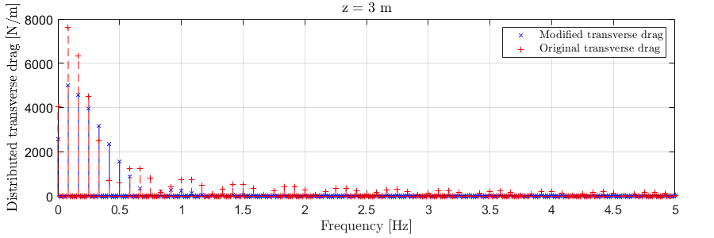

**(a)** Amplitude spectra of the distributed drag at $z=3$ m.

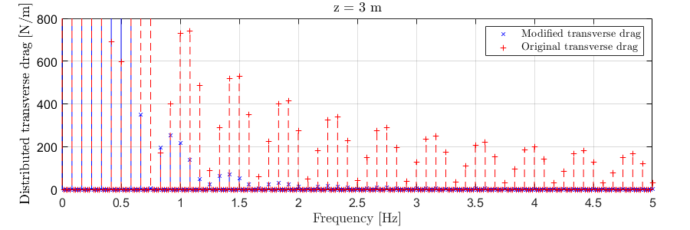

**(b)** Amplitude spectra of the distributed drag at $z=3$ m (zoomed-in).

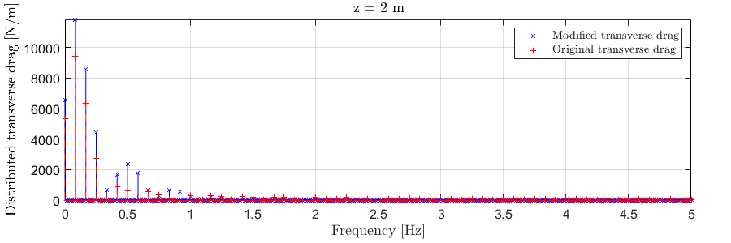

**(c)** Amplitude spectra of the distributed drag at $z=2$ m.

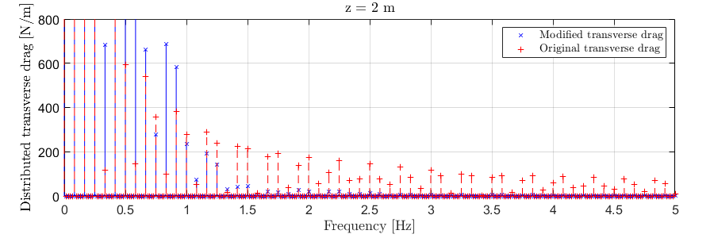

**(d)** Amplitude spectra of the distributed drag at $z=2$ m (zoomed-in).

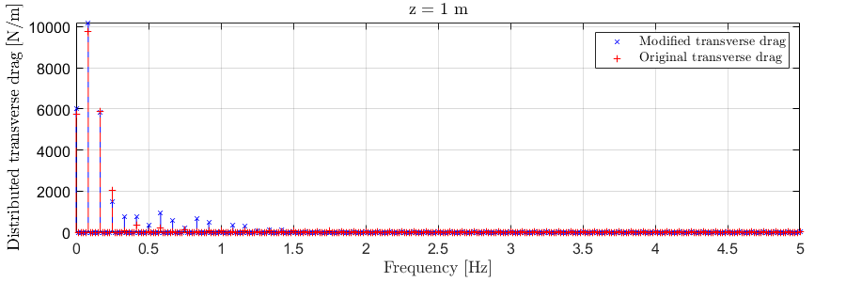

**(e)** Amplitude spectra of the distributed drag at $z=1$ m.

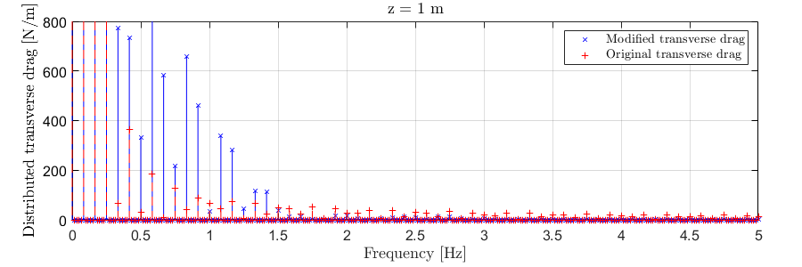

**(f)** Amplitude spectra of the distributed drag at $z=1$ m (zoomed-in).

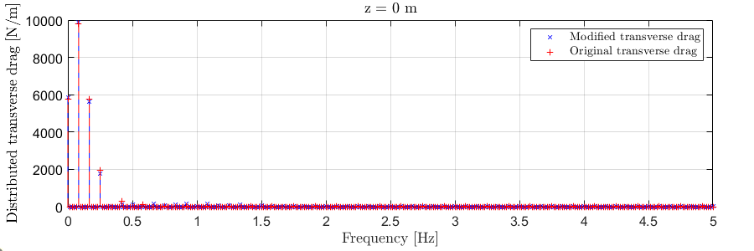

**(g)** Amplitude spectra of the distributed drag at $z=0$ m.

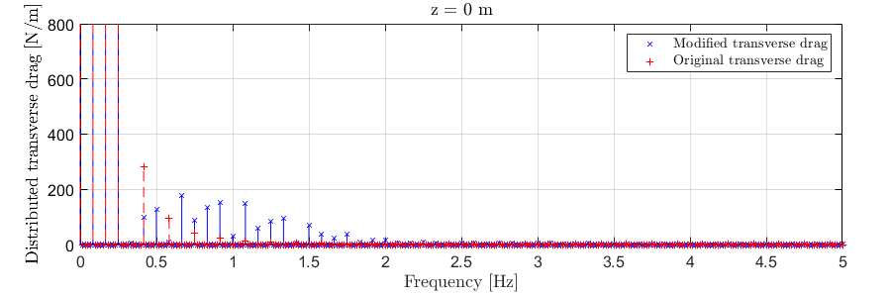

**(h)** Amplitude spectra of the distributed drag at $z=0$ m (zoomed-in).

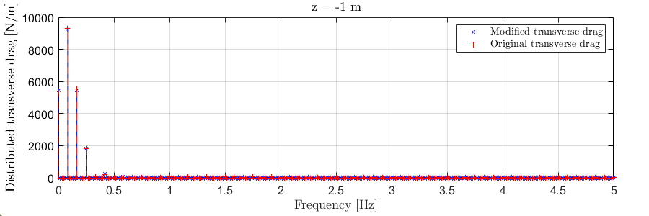

**(i)** Amplitude spectra of the distributed drag at $z=-1$ m.

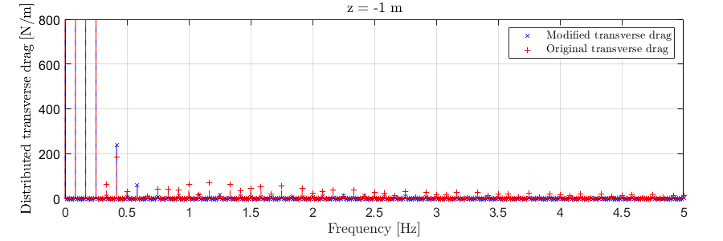

**(j)** Amplitude spectra of the distributed drag at $z=-1$ m (zoomed-in).

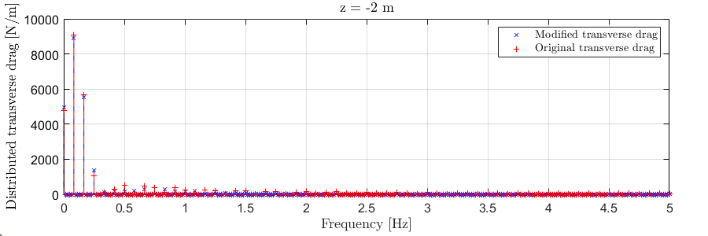

**(k)** Amplitude spectra of the distributed drag at $z=-2$ m.

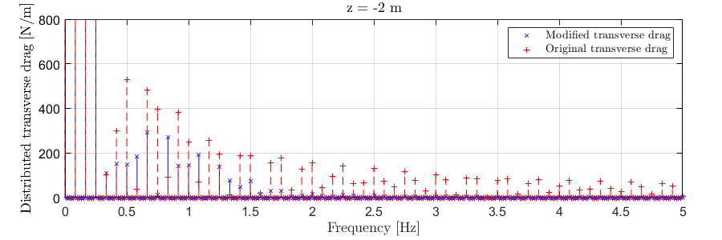

**(l)** Amplitude spectra of the distributed drag at $z=-2$ m (zoomed-in).

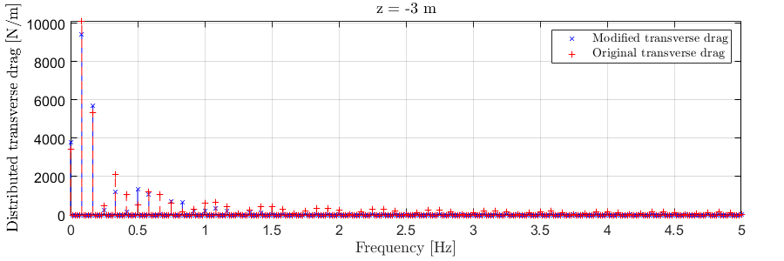

**(m)** Amplitude spectra of the distributed drag at $z=-3$ m.

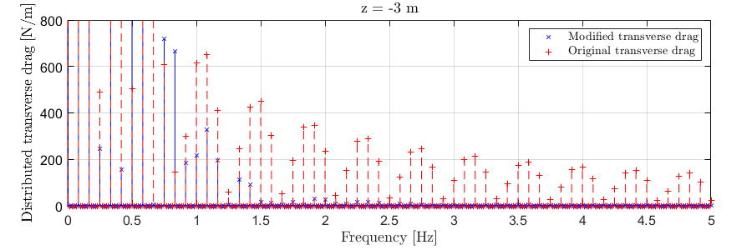

**(n)** Amplitude spectra of the distributed drag at $z=-3$ m (zoomed-in).

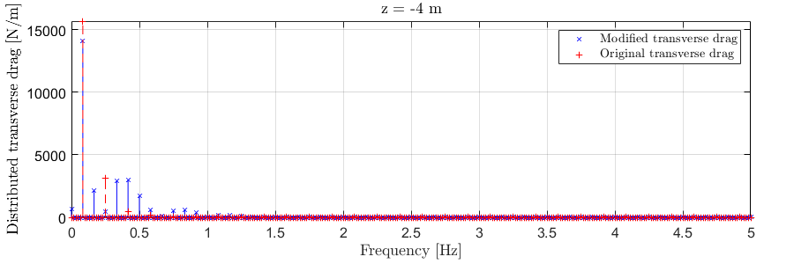

**(o)** Amplitude spectra of the distributed drag at $z=-4$ m.

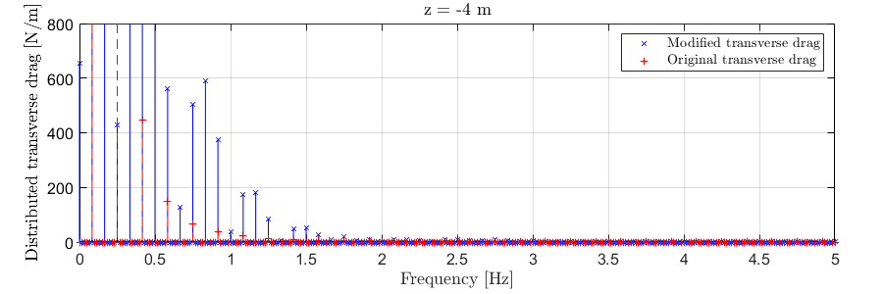

**(p)** Amplitude spectra of the distributed drag at $z=-4$ m (zoomed-in).

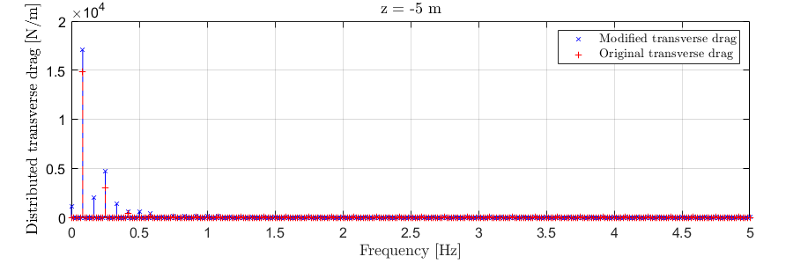

**(q)** Amplitude spectra of the distributed drag at $z=-5$ m.

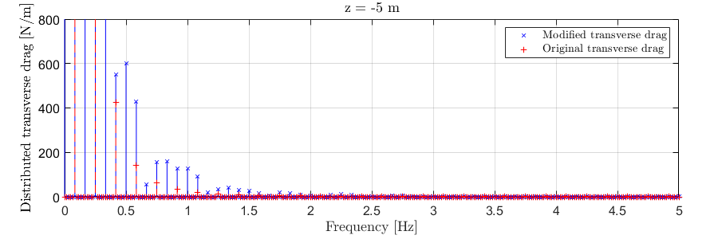

**(r)** Amplitude spectra of the distributed drag at $z=-5$ m (zoomed-in).

**Figure 4**. Amplitude spectra of the distributed transverse drag force at different $z$-sections from $z=-5$ to $3$ m. The still-water level is at $z=0$.

The distributed moment correction is also smooth in time. As examples, the moment at two $z$-sections are shown in Figure 5 below. The moment correction is generally very small and is only non-zero for intermediate submergence. As with the modified force, the moment correction also approaches zero as the submergence decreases further approaching zero. For negative submergence (section out of water), the moment correction is always zero. The amplitude spectra of the distributed moment correction at the two $z$-sections are shown in Figure 6. Two figures are included for each section with the latter zoomed in on the high-frequency components. The moment correction contains some high-frequency components, but the amplitudes are very small.



**(a)** Time series of the distributed moment correction at $z=2$ m.



**(b)** Time series of the distributed moment correction at $z=-4$ m.

**Figure 5**. Distributed pitch moment correction at two $z$-section of $z=2$ m and $-4$ m.



**(a)** Amplitude spectra of the distributed moment correction at $z=-4$ m.



**(b)** Amplitude spectra of the distributed moment correction at $z=-4$ m (zoomed-in).



**(c)** Amplitude spectra of the distributed moment correction at $z=2$ m.



**(d)** Amplitude spectra of the distributed moment correction at $z=2$ m (zoomed in).

**Figure 6**. Amplitude spectra of the distributed pitch moment correction at two $z$-section of $z=2$ m and $-4$ m.

As a final check, the total transverse drag force and the total pitch moment induced by the drag force about $z=0$ are shown in Figure 7. The modification to the transverse load distribution with the moment correction maintains the same total force/moment, which is the desired behavior. The amplitude spectra of the total force and moment are shown in Figure 8. The total loads are divided by the draft of the cylinder to allow comparison with the distributed loads shown previously. The total force and moment show very little high-frequency components. The high-frequency components of the total moment (divided by the draft) are of comparable magnitude as the distributed moment correction shown in Figure 6.

|  |  |
| --- | --- |
|  |  |
| **(a)** | **(b)** |

**Figure 7**. Total drag load on the vertical cylinder based on the modified and the original transverse load distributions. **(a)** Total transverse drag force. **(b)** Total pitch moment induced by the transverse drag.

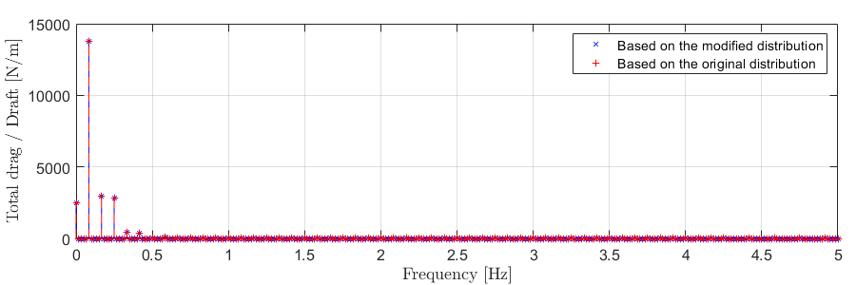

**(a)** Amplitude spectra of the total drag divided by draft.

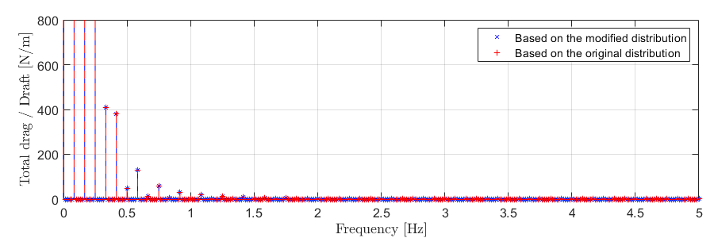

**(b)** Amplitude spectra of the total drag divided by draft (zoomed-in).

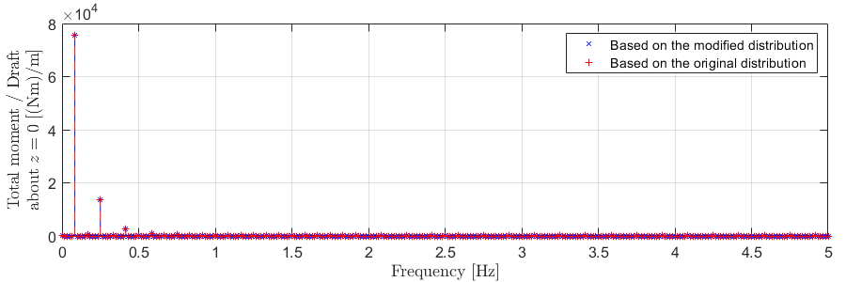

**(c)** Amplitude spectra of the total moment divided by draft.

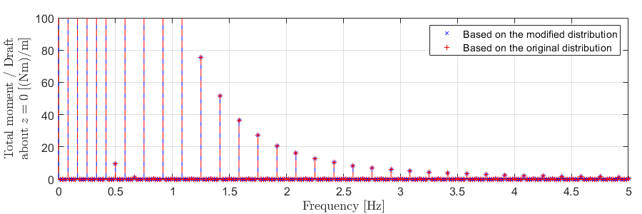

**(d)** Amplitude spectra of the total moment divided by draft (zoomed-in).

**Figure 8**. Amplitude spectra of the total drag load on the vertical cylinder based on the modified and the original transverse load distributions.

*Irregular Waves*

The incident waves are generated using the JONSWAP spectrum with a peak period of $T_{p}=12$ s, a significant wave height of $H_{s}=7$ m, and a peak enhancement factor of $γ=3.3$. The wave spectrum is truncated at $3/T_{p}$. The power spectral densities (PSDs) of the distributed Morison drag force at different $z$-sections are shown in Figure 9. The PSDs of the total drag force divided by the draft of the cylinder are also shown for reference. The decrease in the wide-band high-frequency distributed loads can be observed for frequencies greater than 2 Hz. The section with $z=0$ is an exception because it falls exactly on the still water level, and the original load time series is already relatively smooth. The modification sometimes increases the intermediate-frequency loads approximately between 0.5 Hz and 1 Hz (see, e.g., $z=-4.0$ m). This is likely caused by the presence of the “bumps” in the drag time series at intermediate submergence discussed in the regular-wave example. The total drag loads based on the modified and the original load distributions are identical to each other. The frequency content of the total load decreases more rapidly at higher frequencies compared to the distributed loads, even after modification for smoothness.



**(a)** Log scale.



**(b)** Linear scale (zooming in on the high-frequency components).

**Figure 9**. Power spectral densities (PSDs) of the distributed Morison drag force at different $z$-sections. The total drag force divided by the draft is also shown for reference.

The PSDs of the distributed moment correction at different $z$-sections are shown in Figure 10. The total drag-induced pitch moment on the cylinder divided by the draft is also included for comparison. The distributed moment correction is generally small and decays roughly as fast as the total moment at higher frequencies (see Figure 10a). The total moments computed based on the modified and original load distributions are also identical to each other.



**(a)** Log scale.



**(b)** Linear scale (zooming in on the high-frequency components).

**Figure 10**. PSDs of the distributed moment correction at different $z$-sections. The total drag-induced pitch moment (about $z=0$) divided by the cylinder draft is also shown for reference.

The cumulated PSDs (integrals of the PSDs from zero frequency up to the specified frequency) of the distributed drag forces at the various $z$-sections are shown in Figure 11. To better show the variation of the cumulated PSDs over the high-frequency range, the plots in Figure 11 use different ranges for the modified distributed force (left) and the original force (right), but the scales are the same to facilitate comparisons of the changes over the high-frequency range. As shown in Figure 11, the cumulated PSDs of the original distributed drag continue to increase with frequency over the frequency range shown, indicating the presence of high-frequency load components. On the other hand, the cumulated PSDs of the modified drag flatten out at approximately 3 Hz, showing negligible high-frequency loads beyond this frequency.

|  |  |
| --- | --- |
|  |  |
| **(a) $z=+4$** m | **(b) $z=+2$**  m |
|  |  |
| **(c) $z=0$**  m | **(d) $z=-2$**  m |
|  | |
| **(e) $z=-4$**  m | |

**Figure 11**. Cumulated PSDs of the distributed drag force at various $z$-sections.

1. The wave and current kinematics are undefined outside of the fluid domain. For output purposes, undefined values will be reported as zero. Likewise, hydrodynamic loads are not computed outside of the fluid domain but will be reported as zero for output purposes.